Final Project Report
Computer Animation Techniques
Title of Your Final Project

Submission Date:

Group Members:

Name | Student ID
Name 1 – Group Leader | Student ID-1
Name 2 | Student ID-2
Name 3 | Student ID-3
Table of Contents

Table of Contents ii
Group Members iii
1. Introduction iv
1.1. Related Work iv
1.2. Proposed Work in Assigned Research Paper iv
1.3. Limitations of Proposed Work iv
1.3.1. Critical Review iv
2. Proposed Research Work iv
3. Methodology v
4. Implementation v
5. Results v
6. Conclusion and Future Direction v
7. References v

Group Members:

Name | Student ID | Tasks Assigned **
Name 1 – Group Leader | Student ID-1
Name 2 | Student ID-2
Name 3 | Student ID-3

**Note:
Task assigned can be:

- Understanding the given Research Paper
- Coding of the proposed idea
- Implementation
- Report Documentation
- Presentation

Introduction
Your written report should be in the same format and have the same tone as a research paper published in a scientific journal. It should be an objective report of your results and interpretation.

Related Work
This section briefly explains the summary of existing work in the same field.

Proposed Work in Assigned Research Paper
A summary of the whole paper is to be included in this section.

Limitations of Proposed Work
This section focuses on your analysis of the research paper. What you think are the shortcomings in the research paper assigned to you. And how do you think these limitations could be improved.

Critical Review:
This section you have to write a brief critical review of the research paper.

Proposed Research Work
This section should be concise, yet have enough detail and clarity that someone else could implement your research work easily. Do not write the details about any existing work that are given in a published research paper; rather you should reference each research technique and briefly explain any modifications that you may have made to that research idea. When a research technique has multiple options, be sure to explicitly state the option you are using in your proposed work. This section should include information on:
• What is the basic motivation for your research idea?
From artists not experienced in key-frame animations to highly experienced CG animators. This tool only requires a minimum amount of knowledge of Maya. The user would just need to know how to draw a stroke and specify a model that will move according to that stroke. In general, it can be very useful to concept artists and 3D animators to speed-up the animation pipeline from a 2D Sketch of a model to a full 3D animation. It can also be used by designers to visualize the range of movement a character can perform.
• How is your proposed idea better than the existing research work on the same topic?
Actually, there is no
• The method you used to determine the proposed algorithm.

This section must be written using paragraph format.
You may have modified your implementation from the given research paper during the course of this project. If you are not using the exact method of the proposed research work given in the assigned research paper, then you need to explain the reason as well as those modifications in this section. During the oral presentation, however, you might be asked about the details of your novel idea.

Methodology

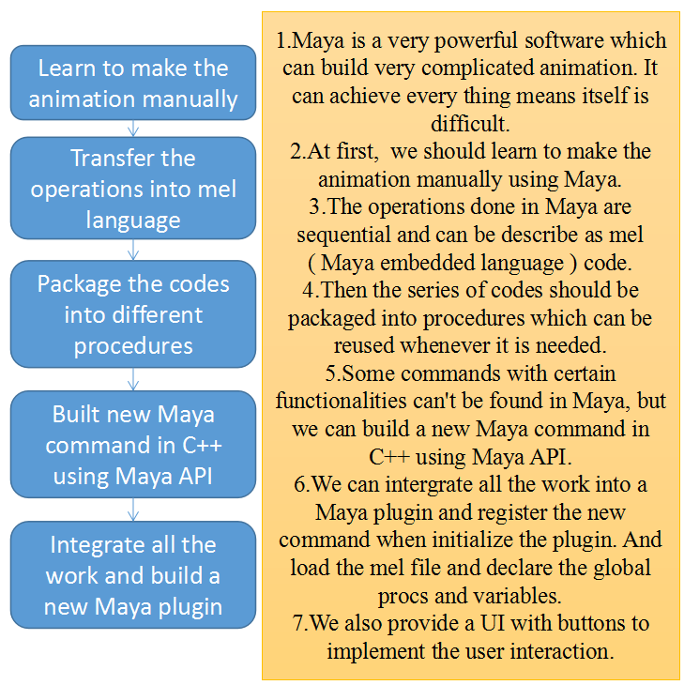

Implementation
Most of the plugin are written in Maya embedded language (MEL) with Maya’s built-in commands and newly created commands and computational nodes coded by C++ using Maya API.
A series of MEL commands can be packaged into a proc (procedure ). So the mel file Window.mel is built up with many different procs.

- UI design:
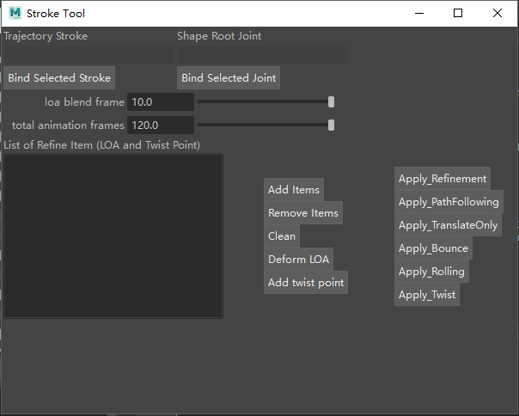
Use rowLayout and columnLayout to arrange the Layout. text, textField, button floatSlideGrp, and textScrollList are the elements used in the windows. When the buttons are clicked, a command would be run.
The first three rows help to select items from Maya and show the names or IDs of the selected ones in the textField.
Each button are bound to a proc that print the names of items in the textField.
global proc BindSelectedTrajectory()
global proc BindSelectedJoint()
Then next two rows use two floatSliderGrp to specify two parameters loa blend frame which means how long is blend time the model use to deform form a orignal shape to a LOA matching shape and total animation frames.
floatSliderGrp -label "loa blend frame" -field true -value 10 -min 1 -max 10 - fieldMinValue 1 -fieldMaxValue 100 sld_blend;
floatSliderGrp -label "total animation frames" -field true -value 120 -min 1 -max 120 - fieldMinValue 1 -fieldMaxValue 500 sld_total;
In the next row, there are three columns, the first two columns contain a textScrollList and several buttons to add the select items in Maya to the textScrollList and show its name or ID in the textScrollList. And remove a LOA or clean all the LOA in the textScrollList.
And clicking the “Deform LOA” Button will deform the joints selected to the LOA.
In the third column, several buttons are shown here to generate the animation according to different situations.
The procs bound to the buttons are listed here and the important ones will be described clearly in the following parts.
Button “Deform LOA” - global proc DeformToLOA();
Button “Deform And Blend” - global proc DeformToLOA();
Button “Apply” - global proc ApplyAnimation();
Button “Apply_PathFollowing” - global proc ApplyAnimation_FlowMotionPath();
Button “Apply_Bounce” - global proc ApplyAnimation_Bounce();
Button “Apply_Rolling” - global proc ApplyAnimation_Rolling();
Button “Apply_PathFollowingWithTwist” - global proc ApplyAnimation_Twist();

2.PathFollowing Animation and Translate only:
pseudocode:
select the trajectory stroke and the Joints of a 3D model;
specify the rootJoint and leafJoint at the very end;
create a ikHandle of the Joints using a mel command ikHandler -sol ikSplineSolver -ns 30 which means ...
set the attribute “dTwistControlEnable” of the newly built ikHandler to 1;
create a pathAnimation of the Joints along the trajectory with flags -follow ( false for PFWithoutDeform and true for PathFollowing );
pathAnimation -fractionMode true -follow true -followAxis x -upAxis y -worldUpType "vector" -worldUpVector 0 1 0 -inverseUp false -inverseFront false -bank false - startTimeU `playbackOptions -query -minTime` -endTimeU `playbackOptions -query - maxTime`;
For PathFollowing Animation: one more command should be run. run flow command to create Lattice and Base for the model and divide to model into pieces to accomplish the deformation when the model is moving along the trajectory curve.
flow -divisions 30 2 2 -objectCentered 1 -localCompute 0 -localDivisions 2 2 2 $ikSplineName;

- Rolling:
Detect loops in the trajectory curve by self Intersection detection.
pseudocode:
global proc float[] GetSelfIntersection(string $c){}
get the spans of a single curve;
detach the curve into spans;
detect if there are intersection between every two spans;
get the u value of the intersection position; (a nurbscurve can be described as f(u)) (there would be two unique u values if there is one loop along the curve)

global proc float[] GetRollingParam(string $curveName){}
there is a redundancy in the result of GetSelfIntersection(), so we need to take the unique values out;

global proc ApplyAniamtion_Rolling(){}
select the trajectory stroke and the Joints of a 3D model;
specify the rootJoint and leafJoint at the very end;
call the proc ApplyAnimation_FlowMotionPath() and get the return as a ikHandle;
set the attribute “ikFkManipulation” of the ikHandle to 1;
get the rolling parameter in the curve;
for every loop in the curve do
get the frames when the model is entering a loop and leaving a loop as blend_in_frame and blend_out_frame;
keyframe the two frames set the “ikBlend” of the ikHandle to 1 showing it still following the path;
in the time from blend_in_frame+1 to blend_out_frame-1 (including the center_frame = (blend_in_frame + blend_out_frame)/2 ), set the attribute “ikBlend” of the ikHandle to 0 in order to make the model stop the deformation according to the path;
setAttr ($ikhandle + ".ikBlend", 0);
setKeyframe { ($ikhandle + ".ikb") };
at the centerframe, set the rotateZ of the rootJoint as the average of the rotateZ of the model at the blend_in_frame and blend_out_frame to make the rotation animation;
done;

4.Refinement of PathFollowing with Over-sketching keyframes:
Over-sketching keyframes are the frames at which the model is matching to the additional LOAs drawn on the trajectory curve and refine the movement.
Just like the bouncing, animation refinement is based on the PathFollowing Animation and with LOA refinement in the middle of the path.
pseudocode:
select the trajectory stroke and the Joints of a 3D model;
specify the rootJoint and leafJoint at the very end;
call the proc ApplyAnimation_FlowMotionPath() and get the return as a ikHandle;
set the attribute “ikFkManipulation” of the ikHandle to 1;
get all the LOAs listed in the textScrollList;
get the blendFrames and totalFrames from the two floatSliderGrp;
for (every LOA in the list) do
get the intersection node of the LOA and trajectory curve.
get postion of the node in the trajectory curve (fraction p : 0-1);
compute the three keyframes p * totalFrame - blendFrames (blend_in_frame) , p * totalFrame + blendFrames (blend_out_frame) and p * totalFrame ( p * totalFrame as the center frame of the refinement ) and set keyframes for the ikHandle.ikb;
in the time from blend_in_frame+1 to blend_out_frame-1, set the attribute “ikBlend” of the ikHandle to 0 in order to make the model stop the deformation according to the path;
setAttr ($ikhandle + ".ikBlend", 0);
setKeyframe { ($ikhandle + ".ikb") };
at the centerframe call the proc DeformToLOA_Pure() to achieve the local-length preserving deformation and make transition animation to and from the centerframe;
DeformToLOA_Pure();
for($j in $childrenJoints)
{
setKeyframe {($j)};
}
done

5.Bouncing (Refinement of translation)
Bouncing is based on the Translation Animation and with LOA refinement in the middle of the path.
pseudocode:
select the trajectory stroke and the Joints of a 3D model;
specify the rootJoint and leafJoint at the very end;
call the proc ApplyAnimation_TranslateOnly() and get the return as a ikHandle;
set the attribute “ikFkManipulation” of the ikHandle to 1;
get all the LOAs listed in the textScrollList;
get the blendFrames and totalFrames from the two floatSliderGrp;
for (every LOA in the list) do
get the intersection node of the LOA and trajectory curve.
get postion of the node in the trajectory curve (fraction p : 0-1);
compute the three keyframes p * totalFrame - blendFrames (blend_in_frame) , p * totalFrame + blendFrames (blend_out_frame) and p * totalFrame ( p * totalFrame as the center frame of the refinement ) and set keyframes for the ikHandle.ikb;
in the time from blend_in_frame+1 to blend_out_frame-1, set the attribute “ikBlend” of the ikHandle to 0 in order to make the model stop the deformation according to the path;
setAttr ($ikhandle + ".ikBlend", 0);
setKeyframe { ($ikhandle + ".ikb") };
at the centerframe call the proc DeformToLOA_Pure() to achieve the local-length preserving deformation and make transition animation to and from the centerframe;
DeformToLOA_Pure();
for($j in $childrenJoints)
{
setKeyframe {($j)};
}
done

6.DeformToLOA
The proc DeformToLOA is a central procedure in the project and it achieves the deformation of a joints skeleton to one that matches the specified LOA curve.

global proc DeformToLOA_Pure()
{
string $root = `textField -query -text tf_rootJoint`;
string $childrenJoints[] = `listRelatives -ad $root`;
string $end = $childrenJoints[0];
CurveIKCmd -root $root -end $end;
//registered command plugin
//CurveIKCmd is going to deal with the deformation
}

CuvreIKCmd is not a built-in command of Maya, it is a command plugin we built using the Maya C++ API.
The basic structure:
class CurveIKCmd : public MPxCommand
{
private:
public:
CurveIKCmd();
virtual ~CurveIKCmd();
static void* creator() { return new CurveIKCmd(); }
MStatus doIt(const MArgList& args);
static bool builtLocalSkeleton;
};
The most important part is the function doIt:
pseudocode: the following only shows simple idea, please refer the source code for detail information.
MStatus CurveIKCmd::doIt(const MArgList& args)
{
- select the curve;
- select the rootJoint and endJoint;
- build the local skeleton along the joints;
- get the length of local skeleton and the new curve and get the strech factor;
- get the new uValue of each joints on the new curve;
- get the length of every bones on the old skeleton and new curve and get the strech vector (only consider the length not the thickness)
- get the rotation axis by compute vector between the new direction of the bone and the old direction of the bone ^ (1,0,0) and the rotation angle by using the Maya command angleBetween;
- make the rotation and scaling of every bone;
- set the position of the rootJoint to the new curve’s start point;
}

Results
- DeformToLOA:
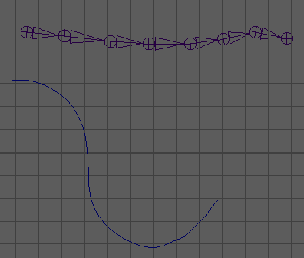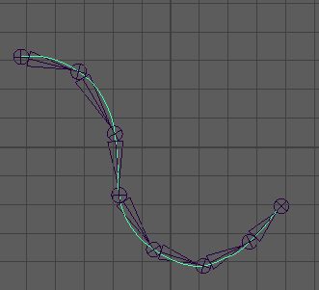
Figure 5.1
First, we test the effect of the deformation by the Command CurveIKCmd.
We can see that every joints are perfectly positioned on the curve and the ratios of lengths between two different bones perverse.

- PathFollowing
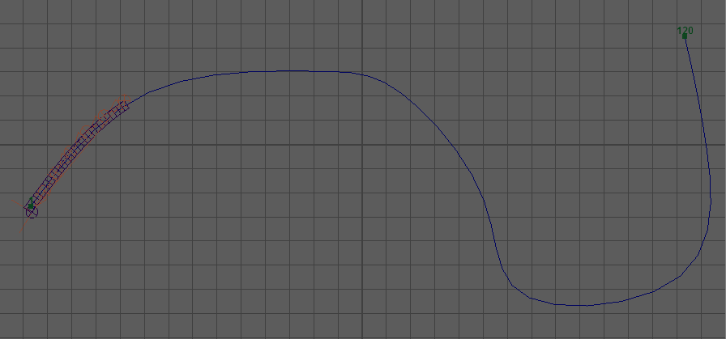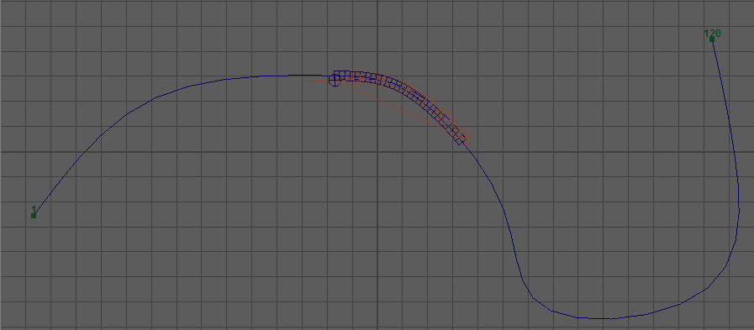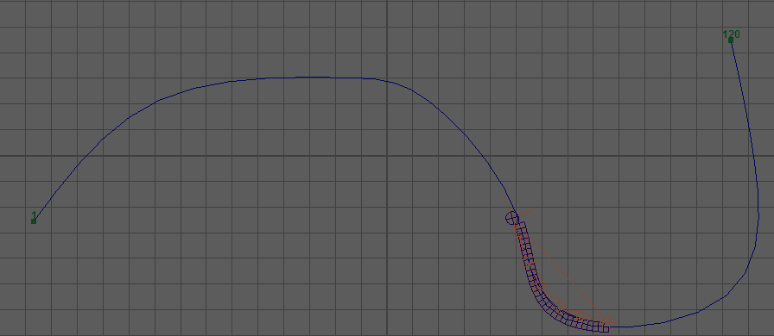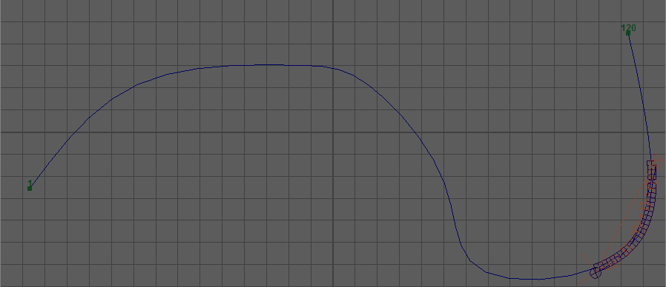
19 frame
51 frame
68 frame
86 frame
Figure 5.2
In the screen shot, we can see that the skeleton is moving along the trajectory curve and the deforming its shape according to the local shape.

- Translation
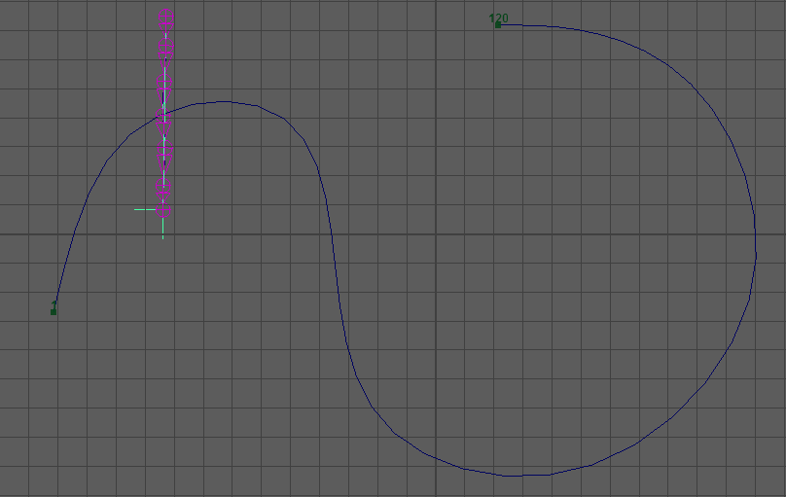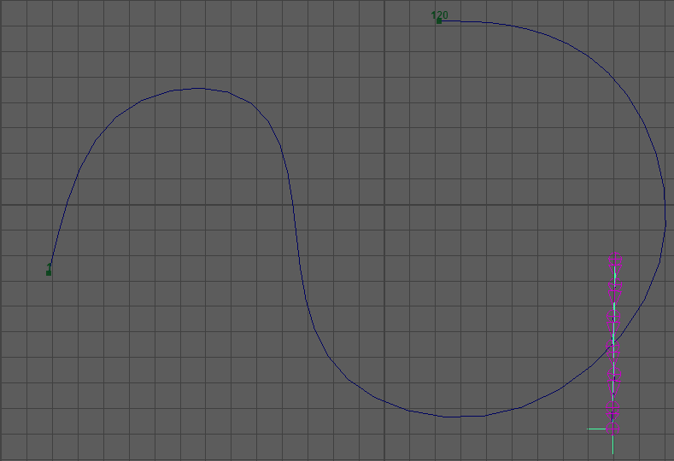
Figure 5.3
Translation just translate the center point of the skeleton along the curve without deformation.
- Bouncing (Refinement of Translation)
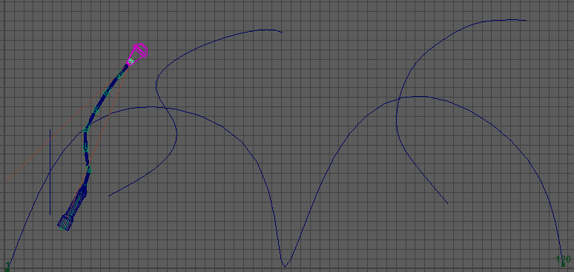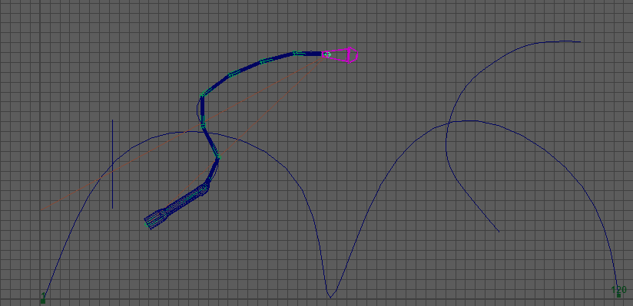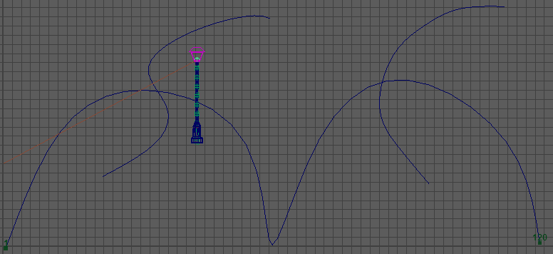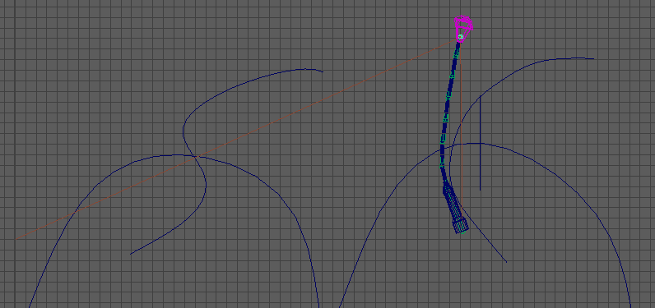
Figure 5.4
Bouncing is aiming at simulate the jumping or bouncing like a human. We need to use LOA along the trajectory curve and insert keyframes in the middle to adjust the poses when the model is moving in the air.
The result shows that we can achieve the animation that the model can deform to the LOA and recover in certain specified blend frames.

- Refinement of PathFollowing
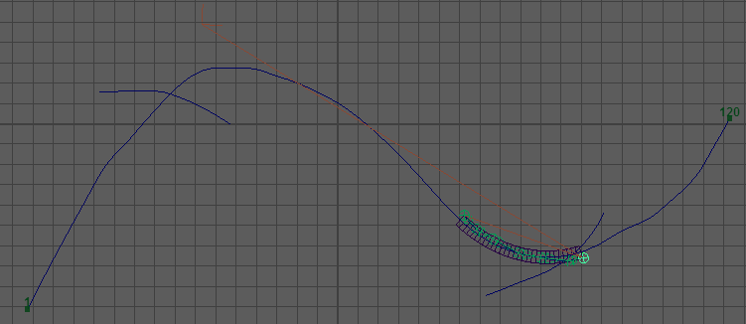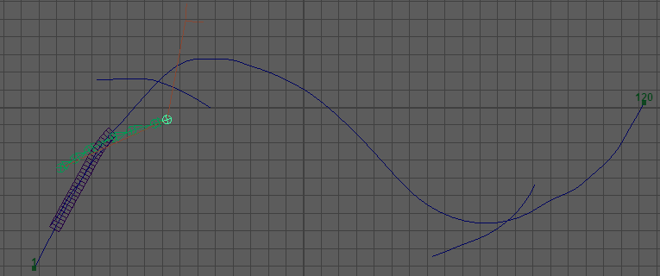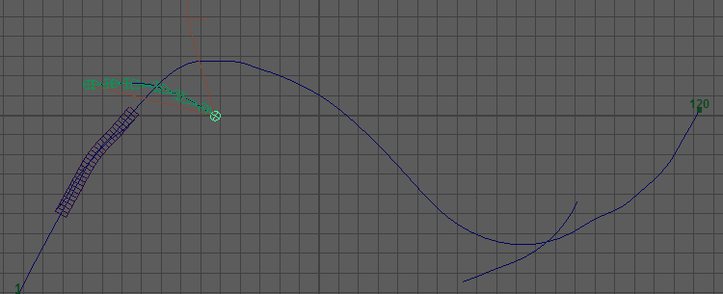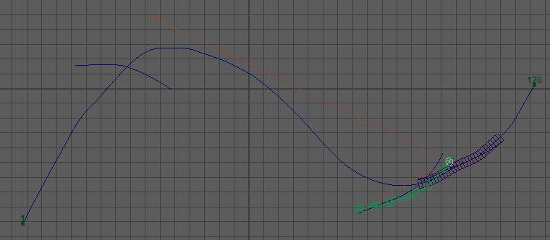
Figure 5.5
During the path following animation, we want to refine the poses of the model using additional LOA.
The result shows that we can successfully animate the model can deform to the LOA and recover in certain specified blend frames.

- Rolling
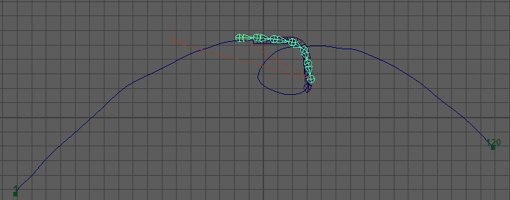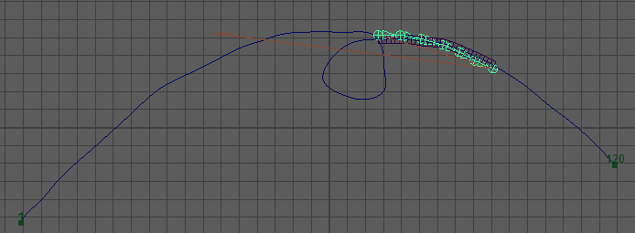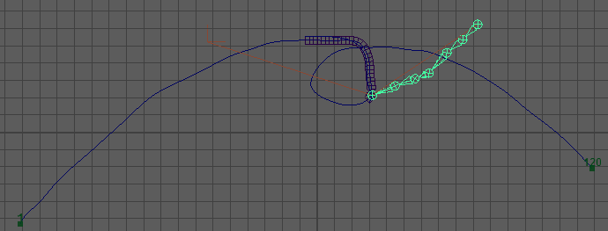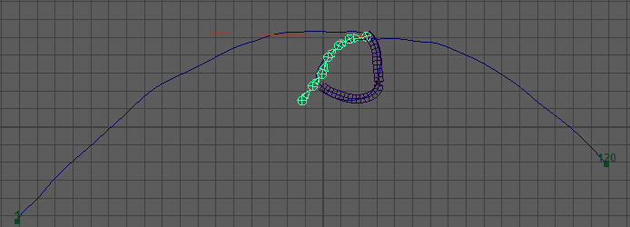
Figure 5.6
One difficult thing about rolling is that if there is a loop in the trajectory curve, the model should rotate its tail to prevent selfcollision.
The result shows our method can avoid selfcollision and give a natural rolling animation of the model.

Conclusion & Future directions
Conclusion
- We build a Maya plugin called StrokeTool. Our tool will free animators from nasty and repetitive key framing processes. With our tool, high quality animation with simple character morphologies can be generated given a trajectory and shape matching strokes. Additional shape matching curve can be added to refine the original automatically generated animations.
- The results shows that we almost achieve the basic idea of the paper. And package it as a Maya plugin that anyone can easily get and deploy in their environment and use it in Maya. And the animations built by our tool have the similar quality of the animations proposed by the paper and the results are consistent with the original paper.
- There are many limitaions in our work. The plugin has some bugs and may doesn’t function well after several times. And the perspectives have some restrictions. And the deformation effects are highly related to the quality of the 3D model. In addition, more work should be done to improve the quality in the future directions.
- In conclusion, we make a Maya plugin to help build animation with space-time sketching.

Future direction
- In the proposed work, we didn’t achieve good effect of rolling and bouncing and didn’t finish the functionality of adding twists to the animation.
- In addition, we should do more work to achieve animation along different axis. And we can make animation such as a dragon flies along with a path and waves its wings at the same time.

References
- 1.http://help.autodesk.com/view/MAYAUL/2017/CHS//
- 2.Martin Guay, R´emi Ronfard, Michael Gleicher, Marie-Paule Cani. Space-time sketching of
character animation. ACM Transactions on Graphics, Association for Computing Machinery,
2015, 34 (4), pp.1. <10.1145/2766893>. <hal-01153763>
- 3.https://github.com/shrekshao/AnimationSketcher

